HR ATTRITION ANALYSIS USING PYTHON & POWER BI

Project Report

Submitted By
Lenka Dinesh

Internship Details

Project Title | HR Attrition Analysis
Tools Used | Python, Pandas, Numpy, SQL, Power BI
Dataset | HR Employee Attrition

Dataset Understanding in Python:

- Import Libraries
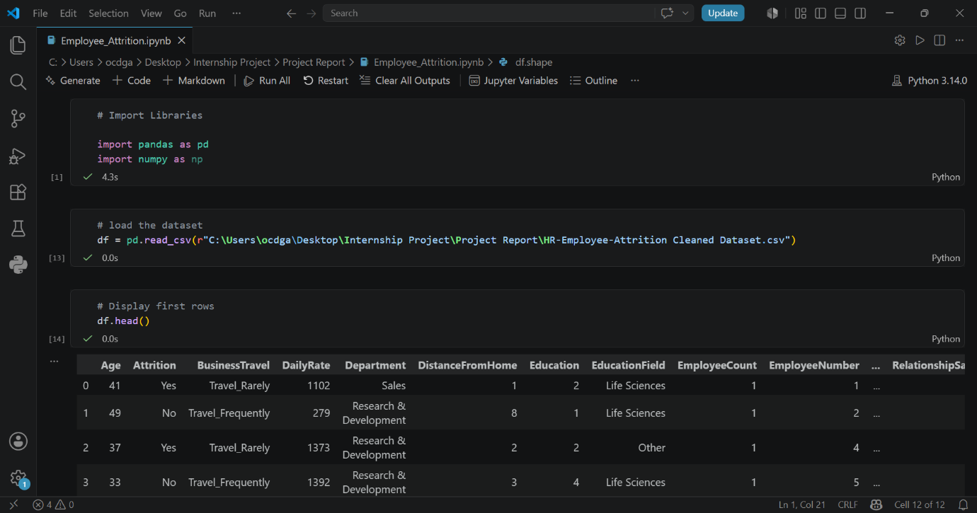
- Load dataset
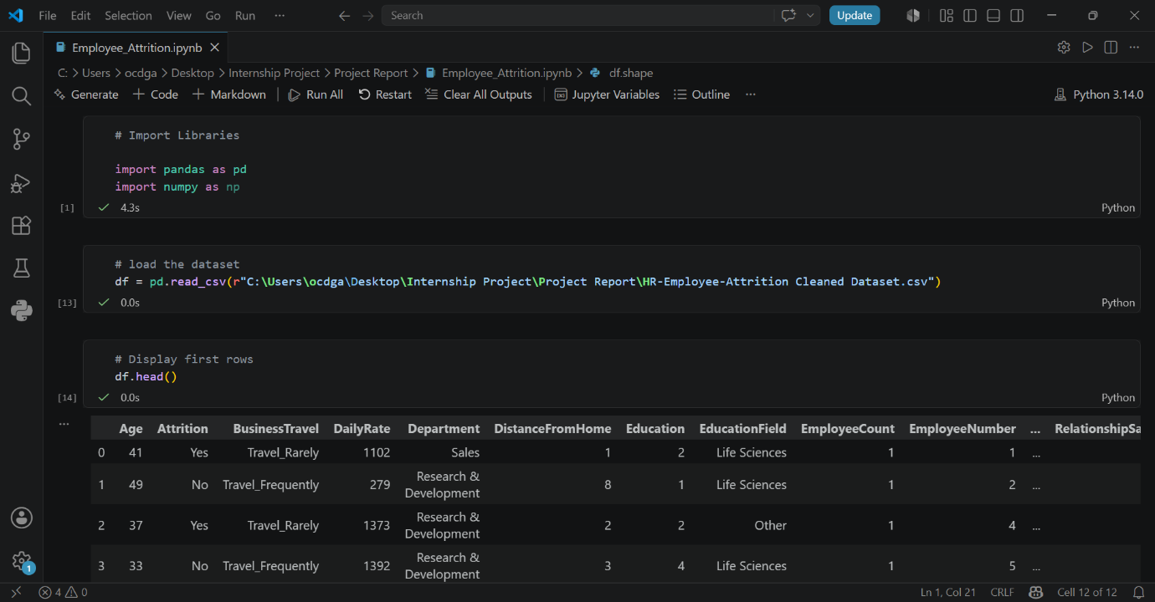

- Rows and Columns
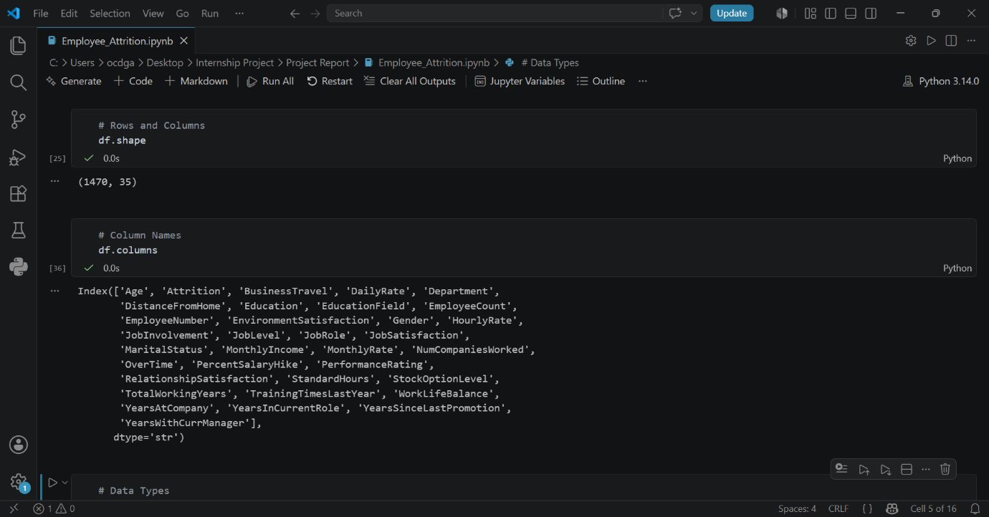
- Columns Names


- Dataset Information
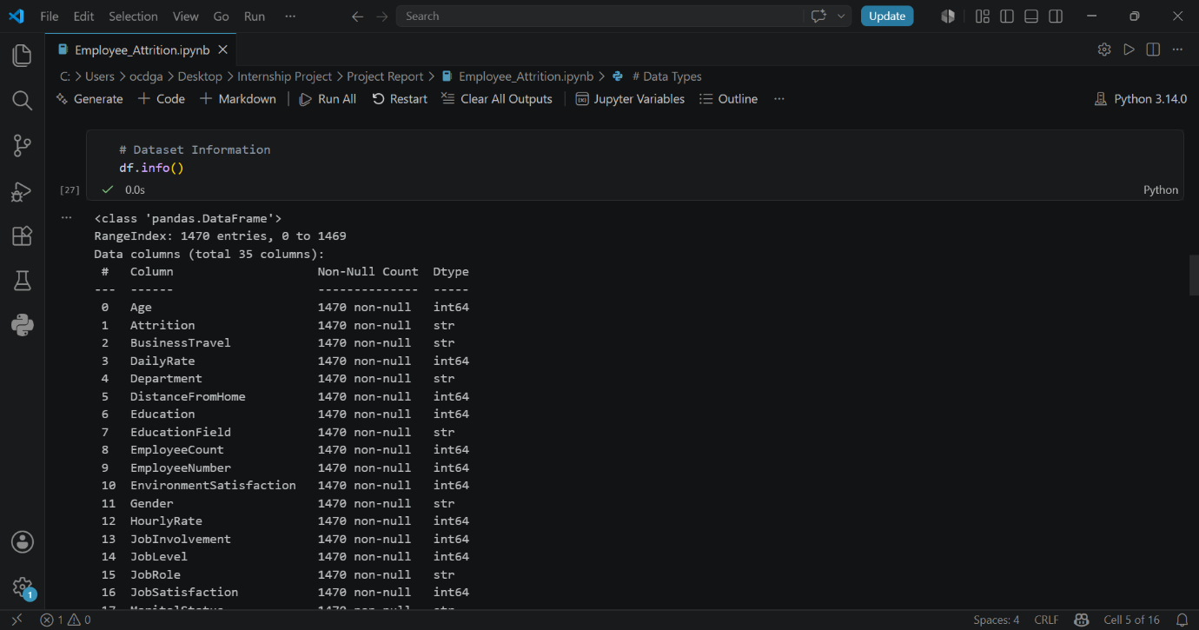
- Display First rows
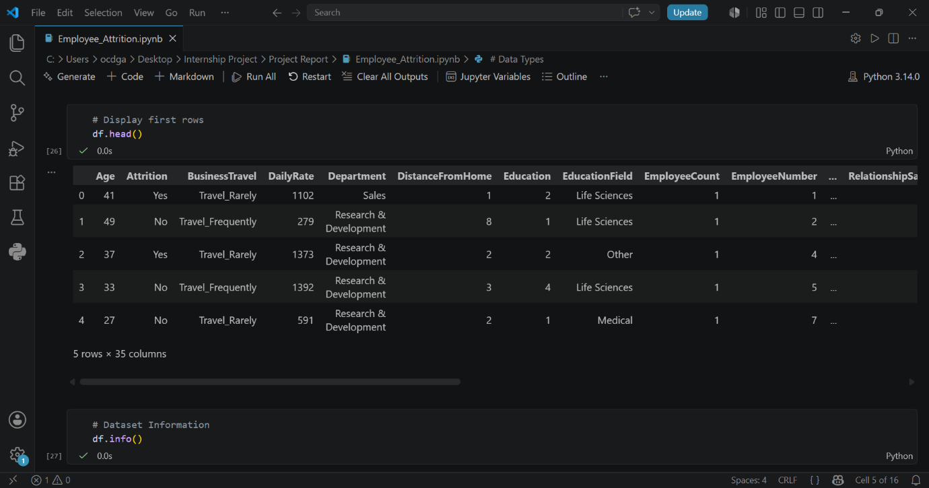
- Statistical Summary
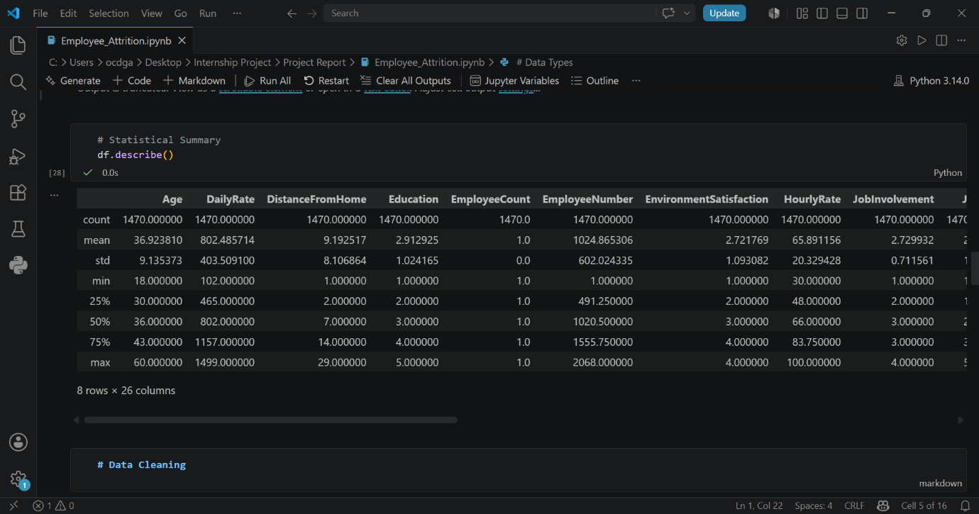

Data Cleaning in Python:

- Findout Missing values
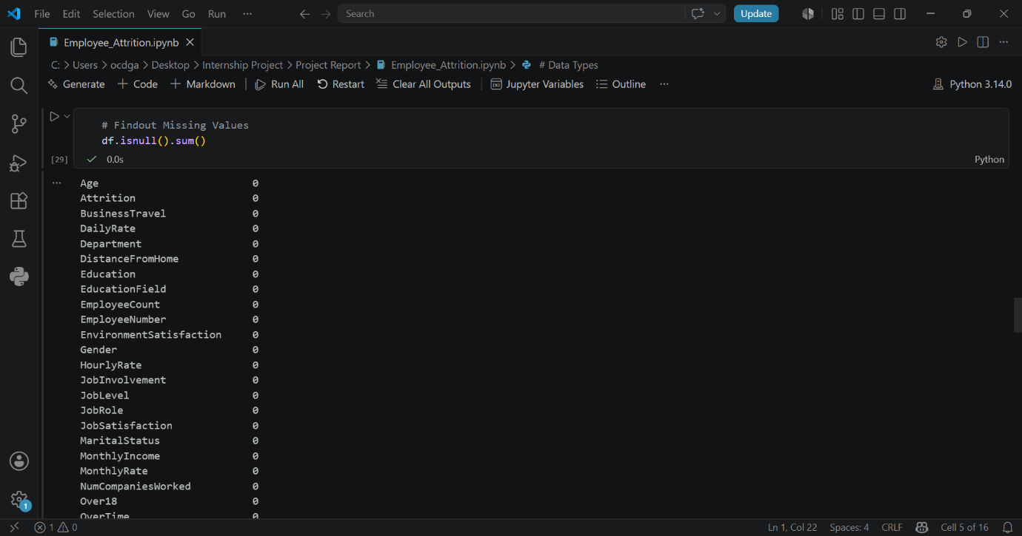

- Findout Duplicate values
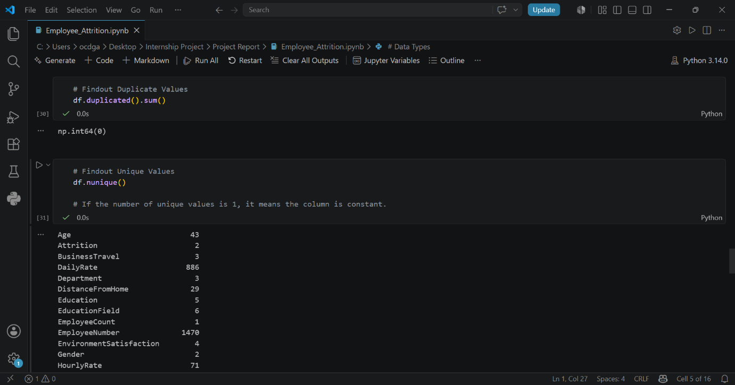
- Findout unique values

- Removing unnecessary columns

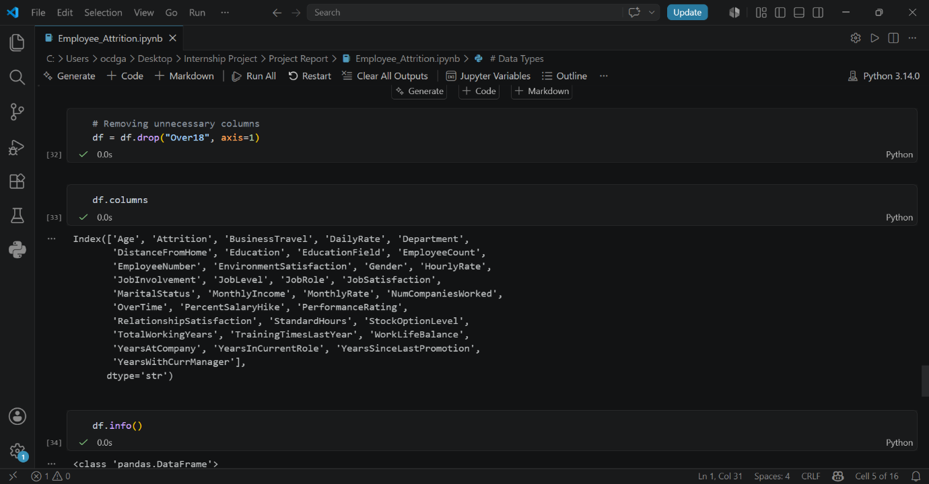

- Column names
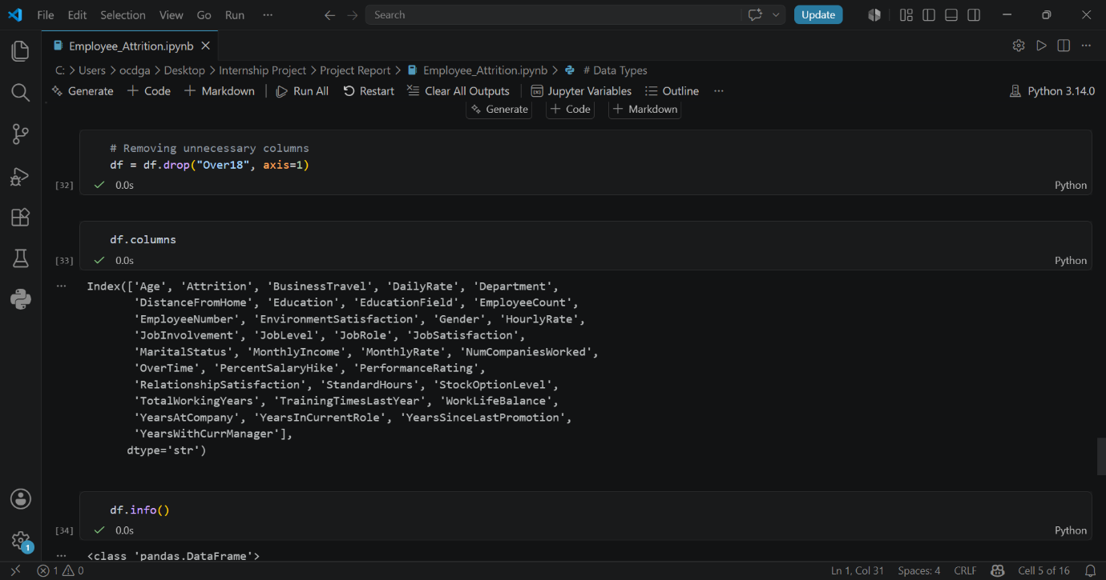
- Data frame Information
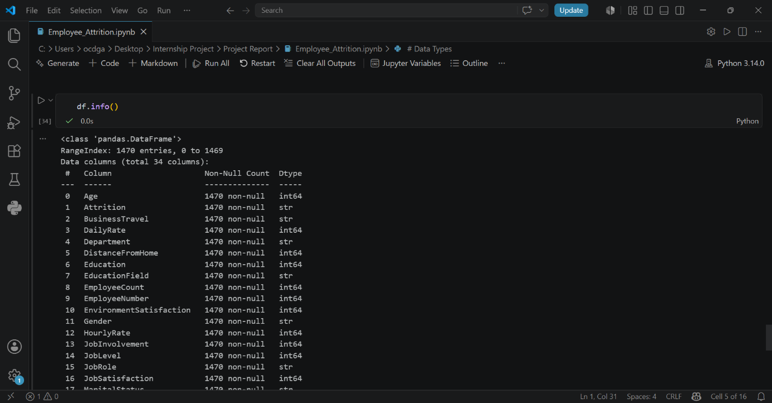

- Dataframe Rows and Columns
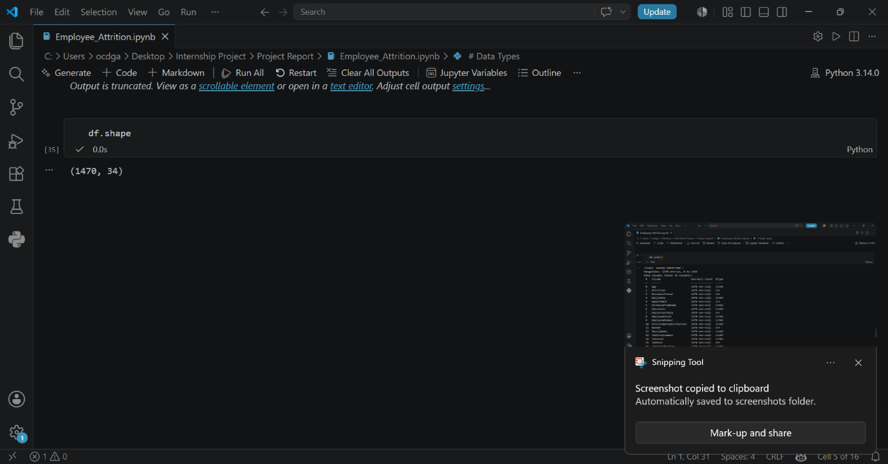

During data cleaning, the columns EmployeeCount, Over18, and StandardHours were identified as constant columns because each contained only a single unique value across all records. Since these columns did not provide any variability or analytical value, they were removed from the dataset to simplify the analysis and improve data quality.
- No missing values found
- No duplicate records found
- Dataset is clean and ready for analysis

Exploratory Data Analysis (EDA):
- Employee Attrition Count
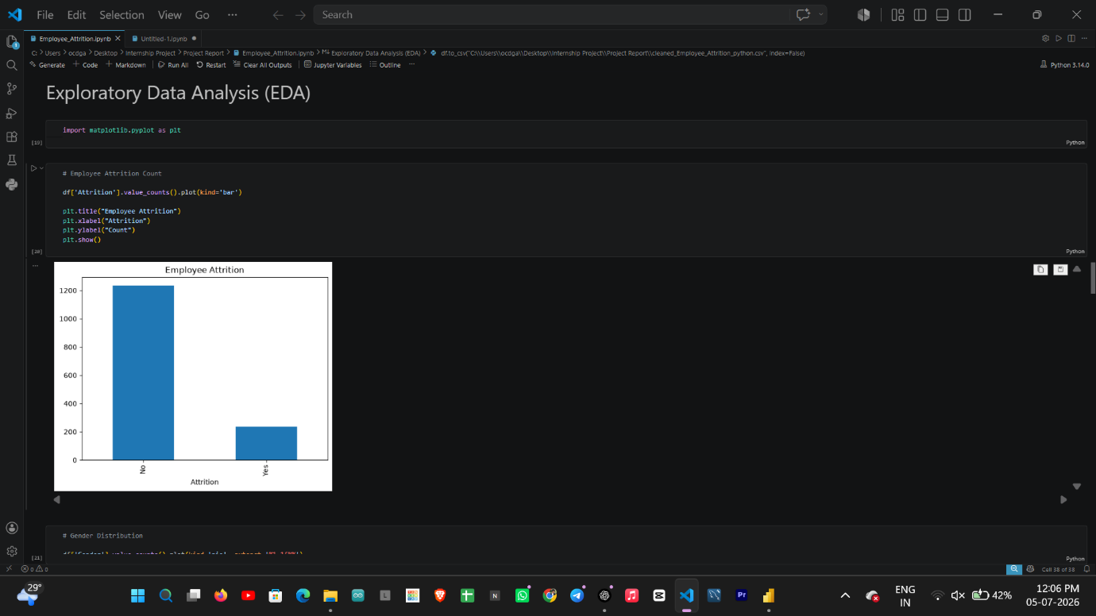
- Department Distribution
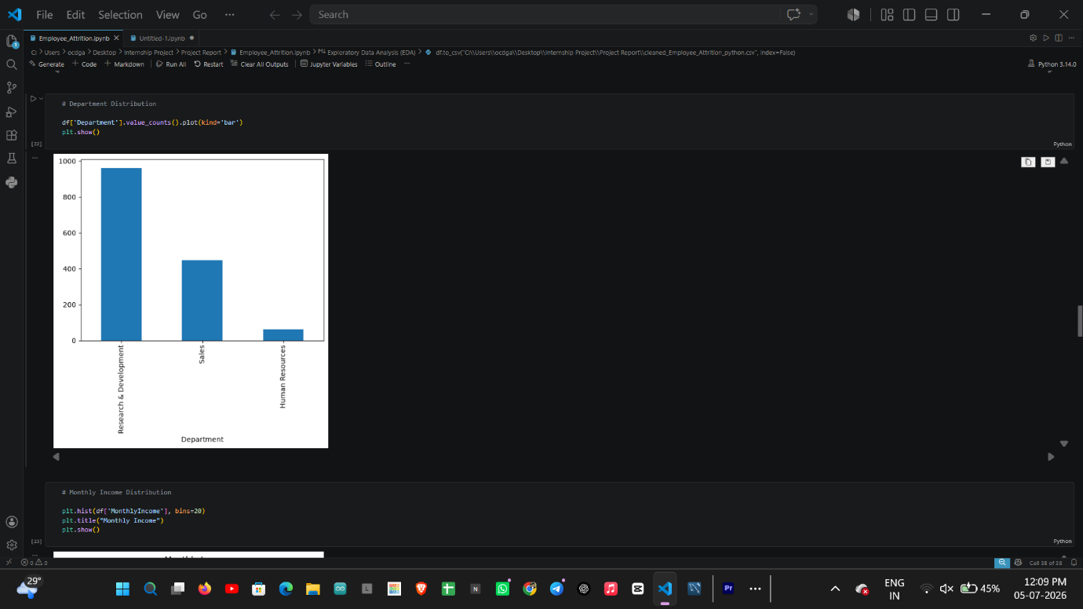
- Gender Distribution
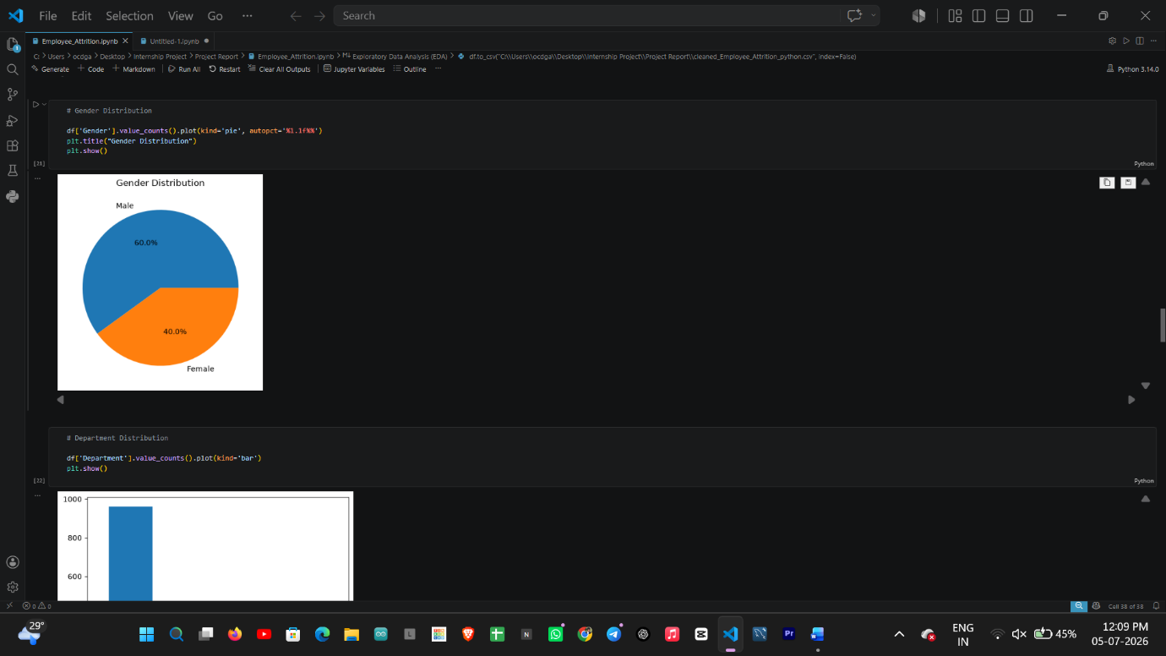

- Age Distribution
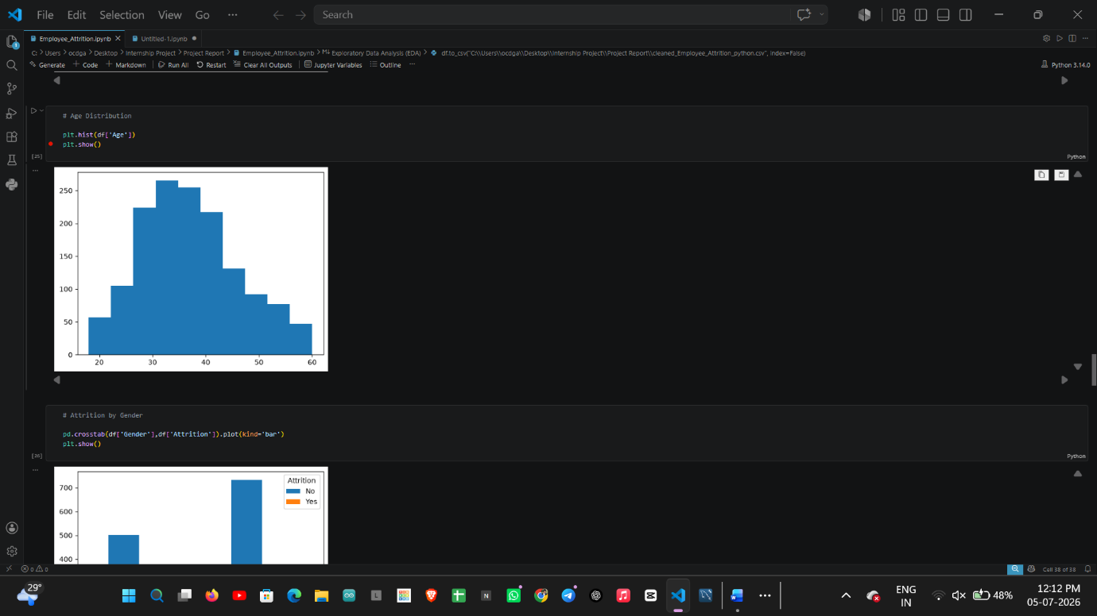
- Monthly Income Distribution
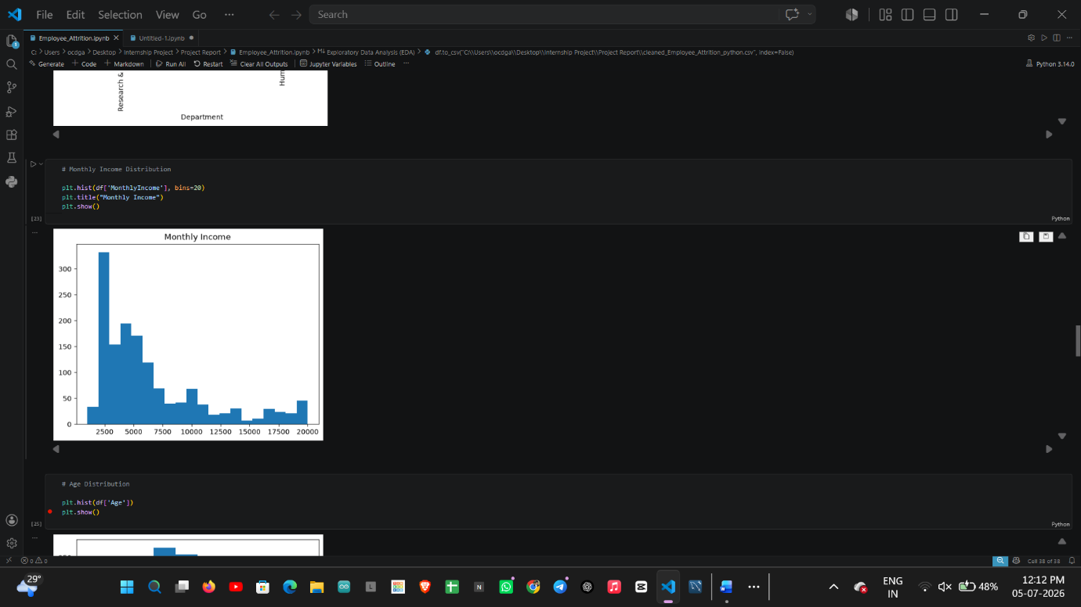
- Attrition by Department
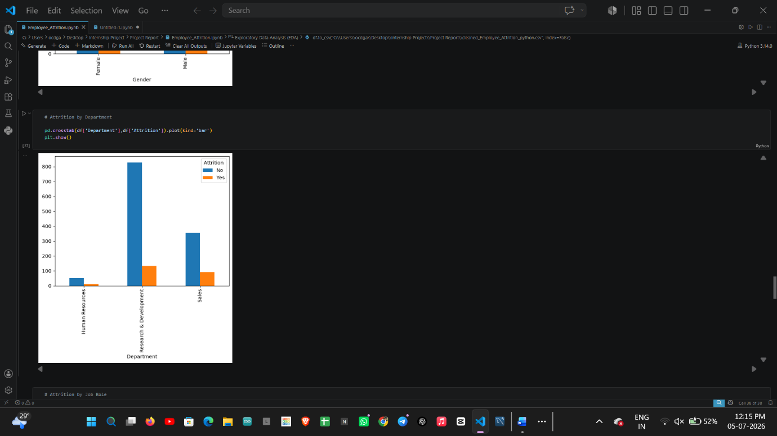

- Attrition by Gender
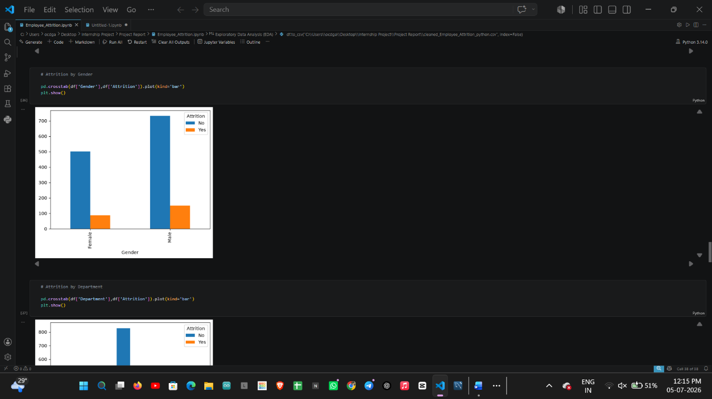

- Attrition by overtime
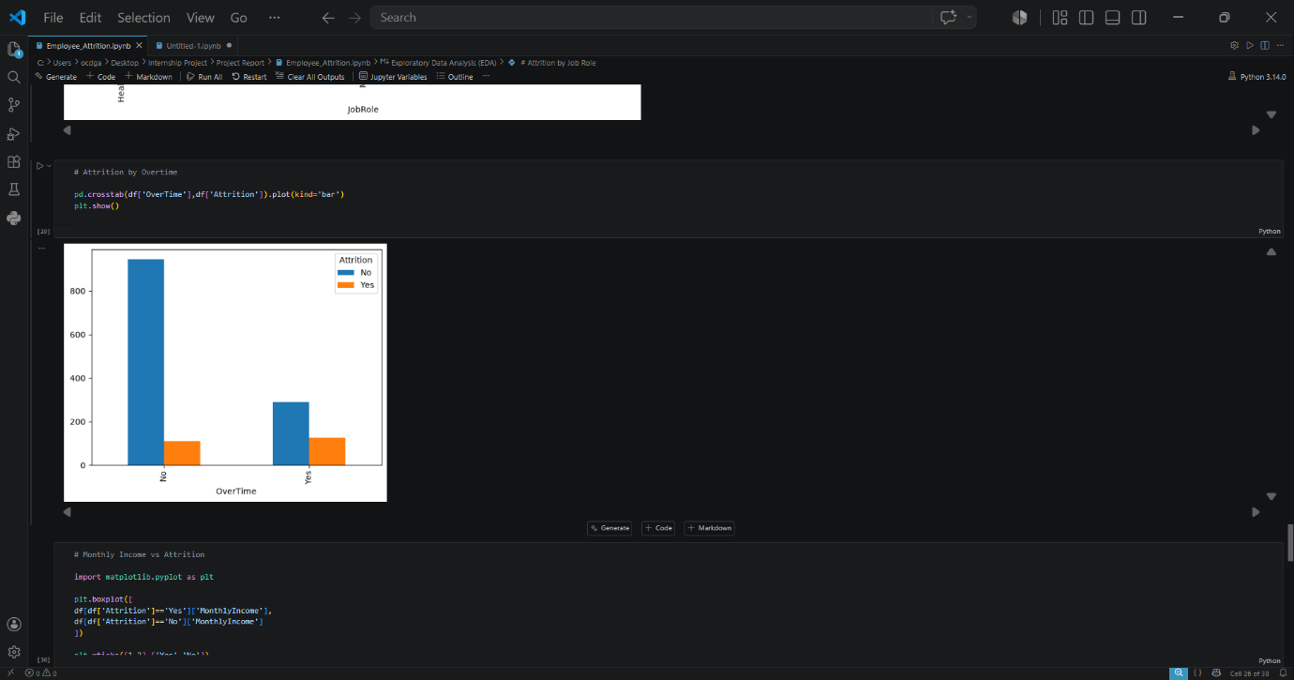
- Attrition by Job Role
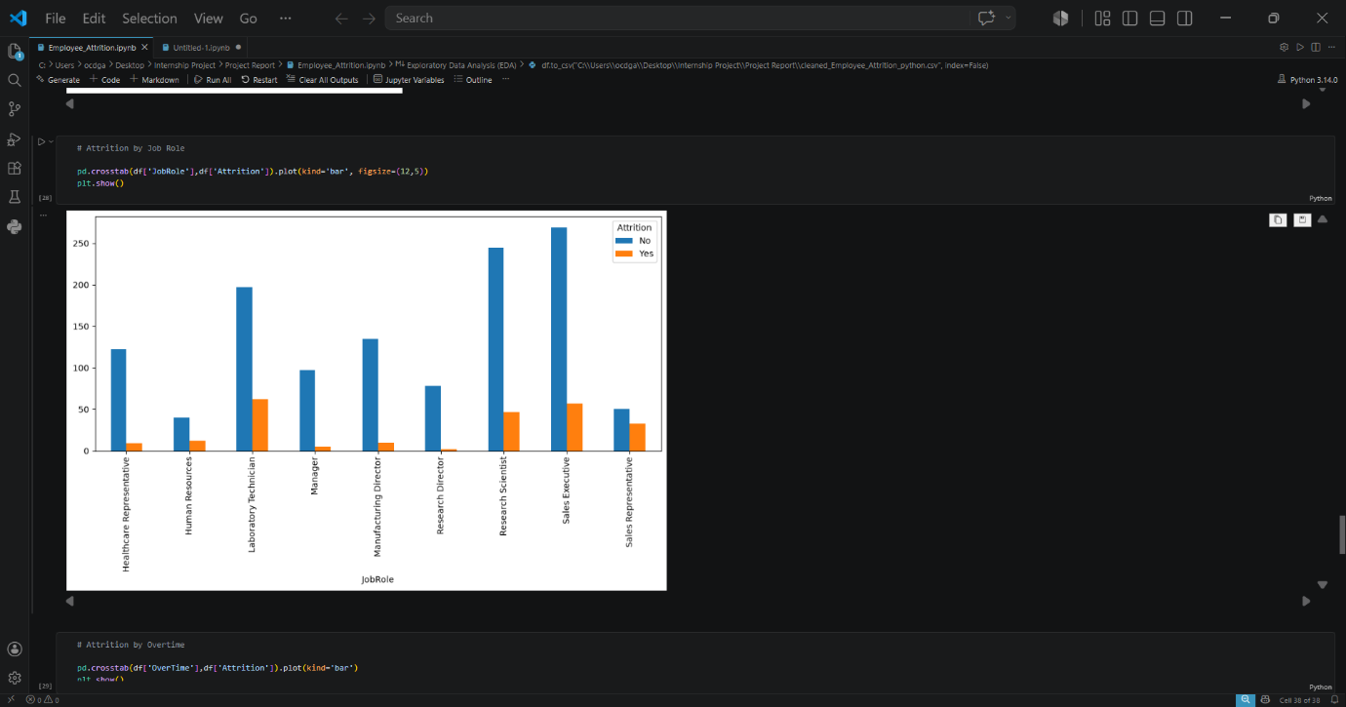

- Attrition by Overtime

- Monthly Income vs Attrition
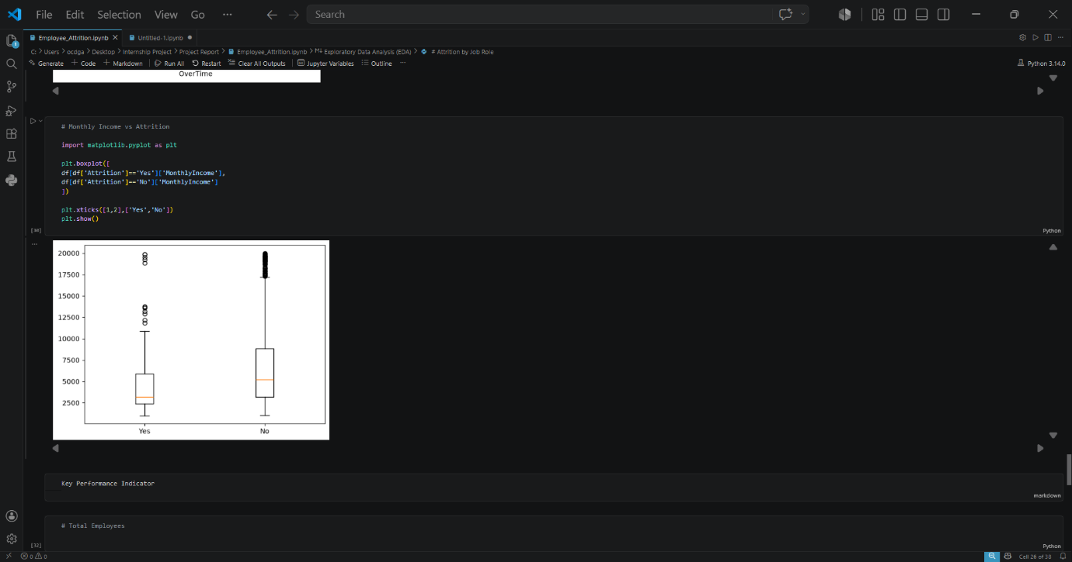

Key Performance Indicator (KPI’s)

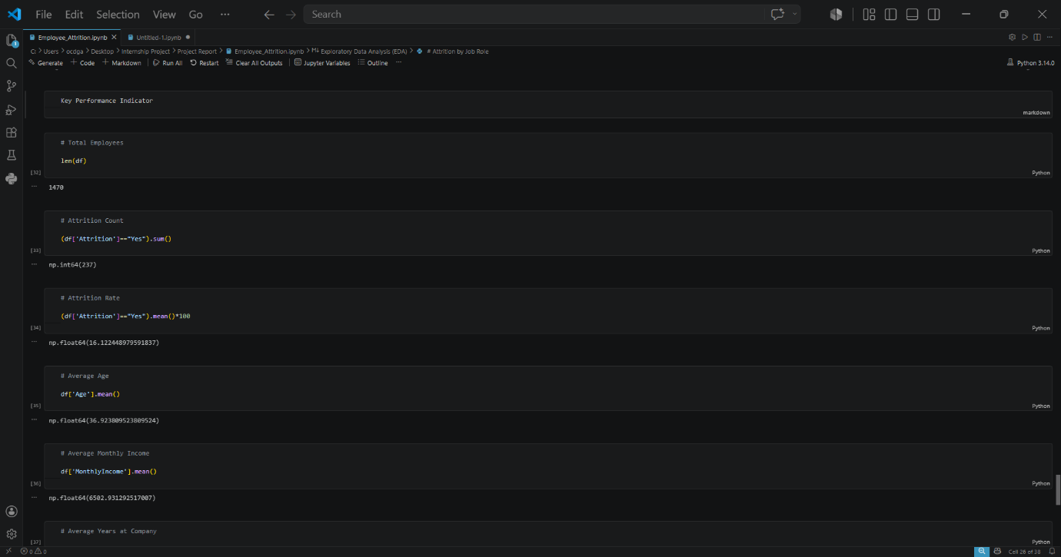

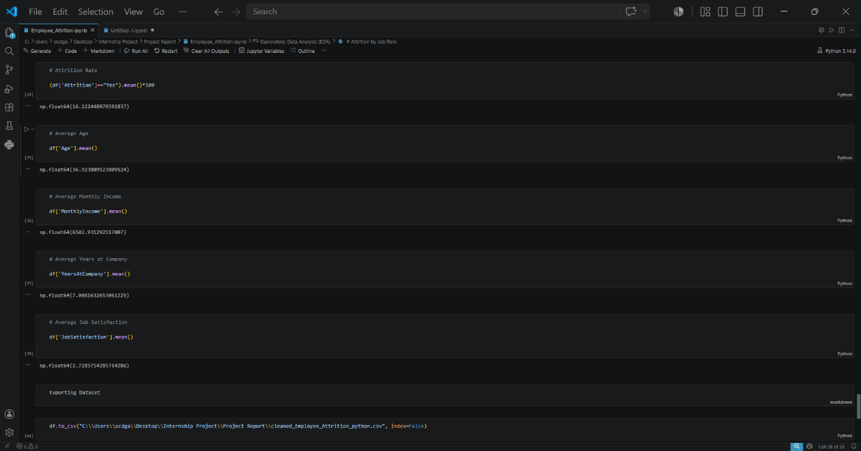

  - Exporting Dataset:
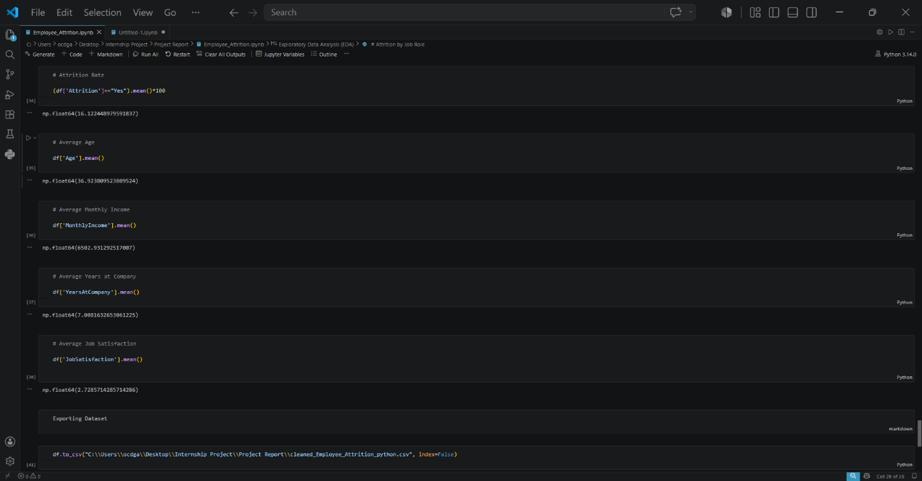

Data Integration and Dashboard Development

After completing the data cleaning and preprocessing in Python using the Pandas library, the cleaned employee attrition dataset was exported and uploaded into a MySQL Workbench database. The MySQL server served as the centralized data source for the project.
Power BI Desktop was then connected to the MySQL database using the MySQL Connector. The dashboard was developed by importing the cleaned data directly from the MySQL server, ensuring a structured and database-driven workflow. This approach demonstrates an industry-standard ETL (Extract, Transform, Load) process, where data is cleaned in Python, stored in a relational database, and visualized using Power BI.
The Power BI dashboard includes key HR metrics such as Total Employees, Attrition Count, Attrition Rate, Average Age, and Average Monthly Income. Interactive visualizations were created to analyze employee attrition across various dimensions, including department, job role, overtime, salary, work-life balance, job satisfaction, education field, and years at the company. Slicers were added to enable dynamic filtering and improve dashboard interactivity
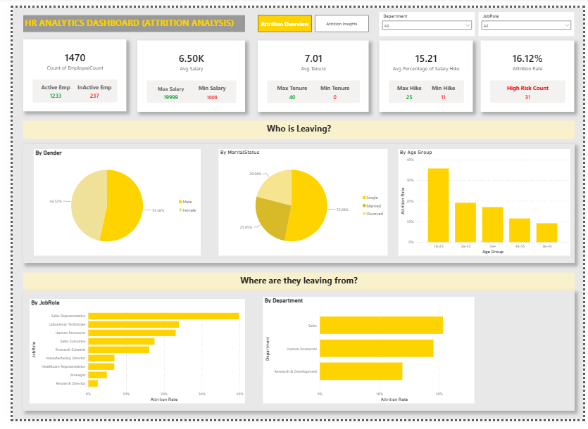

Objective
The Employee Attrition Overview Dashboard provides a comprehensive summary of the organization's workforce. It enables HR managers to monitor overall attrition trends, employee distribution, salary statistics, tenure, and demographic characteristics. The dashboard helps identify which employee groups are leaving the organization and highlights departments and job roles with higher attrition.

Key Insights
- The organization has 1,470 employees.
- The overall employee attrition rate is 16.12%.
- 237 employees have left the organization.
- The Sales department experiences the highest employee attrition.
- Laboratory Technicians and Sales Executives contribute significantly to employee turnover.
- Employees between 18–25 years exhibit the highest attrition rate.

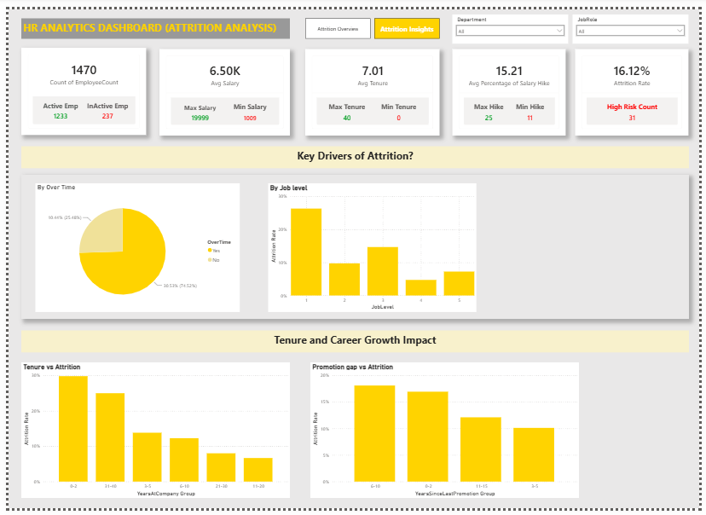

Objective
The Employee Attrition Insights Dashboard focuses on identifying the major factors influencing employee turnover. It examines overtime, job level, employee tenure, and promotion history to understand why employees leave the organization.

Key Insights
- Employees working overtime have a higher attrition rate than employees who do not work overtime.
- Employees with lower job levels exhibit higher turnover.
- Most resignations occur within the first few years of employment.
- Employees who wait longer for promotions tend to leave more frequently.
- Early-career employees require stronger engagement and career development programs.

Business Insights :
- The overall employee attrition rate is 16.12%, indicating a moderate level of workforce turnover.
- Sales and Human Resources departments experience comparatively higher attrition.
- Employees aged 18–25 years are more likely to resign than other age groups.
- Overtime is strongly associated with employee attrition.
- Lower job levels experience greater employee turnover.
- Employees in the early stages of their careers show a higher likelihood of leaving the organization.
- Delayed promotions appear to contribute to increased employee attrition.

Conclusion
This project successfully analyzed employee attrition using Python, MySQL, and Power BI to identify the major factors influencing employee turnover. The raw employee dataset was cleaned and pre-processed using Python, ensuring data quality and consistency. The cleaned dataset was then stored in a MySQL database, which served as the data source for Power BI to create interactive dashboards.
Through exploratory data analysis and dashboard visualizations, several important patterns were identified. The analysis showed that employee attrition is influenced by factors such as overtime, department, job role, age group, job level, tenure, salary, and promotion history. The interactive dashboards enabled dynamic exploration of these factors and provided a comprehensive overview of workforce trends.
Based on the findings, practical business recommendations were proposed, including improving work-life balance, enhancing career development opportunities, reducing excessive overtime, strengthening employee engagement, and implementing competitive compensation and recognition programs. These recommendations can help organizations reduce employee turnover and improve workforce retention.
Overall, this project demonstrates how data analytics and business intelligence tools can transform raw HR data into meaningful insights that support strategic decision-making. It also highlights the integration of Python for data preprocessing, MySQL for database management, and Power BI for interactive reporting, providing an end-to-end analytics solution for employee attrition analysis.

